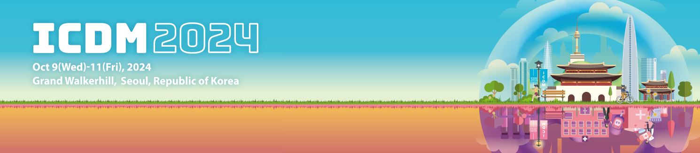

**Request for Cancellation of 14th ICDM Registration**

※ Please fill out the form and send it to the congress secretariat at [icdm@diabetes.or.kr.](mailto:icdm@diabetes.or.kr.)

**I. Personal Information**

|  |  |  |  |
| --- | --- | --- | --- |
| **ID** |  | **Membership** | **□ Member □ Non-member** |
| **Name** |  | **Profession** |  |
| **Organization** |  | **Date of Birth** | (i.e. 1980-Nov-16) |
| **Phone** |  | **E-mail** |  |
| **Credit Card No.** |  | **Credit Card Vendor** |  |

**II. Cancellation of Registration**

|  |  |  |  |
| --- | --- | --- | --- |
|  | **Early registration**  **(~2 September 2024)** | | |
| **Domestic** | | **International** |
| **Member** | **Non-Member** |
| **Full registration (Regular rate)** | [ ] USD 280 | [ ] USD 350 | [ ] USD 280 |
| **Full registration**  **(Reduced rate)** | [ ] USD 180 | [ ] USD 230 | [ ] USD 180 |
| **One-day registration (Regular rate)** | [ ] USD 170 | [ ] USD 210 | [ ] USD 170 |
| **One-day registration**  **(Reduced rate)** | [ ] USD 110 | [ ] USD 140 | [ ] USD 110 |
| **Low-income countries** | [ ] USD 150 | | |
| **Gala Dinner** | [ ] USD 55 **Cancelling only for gala dinner is not possible.**  **If you wish to cancel the dinner, please cancel your**  **entire registration and re-submit your payment.** | | |

**NOTE**

- Cancellation of registration is only acceptable in written form BEFORE the deadline of registration.

|  |  |
| --- | --- |
| By 2 September 2024 | 100% refund |
| From 3 September 2024 | No refund |

*I hereby request the cancellation of 14th ICDM registration.*

**YYYY/MM/DD Name (Signature)**